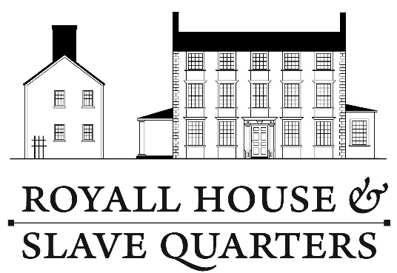

Giving Voice ~ June 5, 2016
An Afternoon with Playwright Kirsten Greenidge

Reserve Tickets:

_____ # of tickets at Member rate of $40

_____ # of tickets at Non-Member rate of $50

Tickets will be held at the door.
Ticket price is tax deductible less $10.

I would like to support the museum with a donation of $ _________.

Donation levels: All donations are fully tax deductible.

Benefactor $500 Donor $100
Supporter $250 Friend $25 - $99

Please list me in the event materials as ____________________________________

Total enclosed: $ _________ Thank you for your support.

Name(s) _______________________________________________________________

Email _________________________________________________________________

Address _______________________________________________________________

_______________________________________________________________________

Please print this page and mail with your check to:

Royall House and Slave Quarters
15 George Street
Medford, Massachusetts 02155

